Report # 5:

Errors and Bugs Report  
URL: <https://takingmyclassesonline.com/>

Effective Dated: 7th November 2024

Homepage:

# 1: Anchor links

 If you are looking for an expert to take your online classes, then you don’t need to think about [‘pay someone to take online class’.](https://takingmyclassesonline.com/pay-someone-to-take-my-class) Just join our classes because we are here to help you achieve your objective and grow your learning journey. Believing in us, our online classes offer hands-on assistance and support so you can remove any academic hurdle.

Note: Correct above anchor link to: ‘[pay someone to take online class](https://takingmyclassesonline.com/pay-someone-to-take-my-class)’. Don’t anchor on ‘.

2.   
Today’s world is moving towards virtual opportunities. With the advent of AI, technology, and better internet connections worldwide, taking online classes has become common. You can enrol in an online class anywhere. If you write on Google [‘do my exam online’](https://takingmyclassesonline.com/take-my-exam) , you will find a number of services.

Note: Correct above anchor link to: ‘[do my exam online](https://takingmyclassesonline.com/take-my-exam)’, you will – Note: Don’t anchor on ‘.

3.

Our packages have been adjusted to consider your financial burdens when pursuing ‘take my online classes’ or ‘Do My Classes for Me’. You can use our live support service to discuss the price or just write,[‘How much is it to take the GRE?’](https://takingmyclassesonline.com/take-my-gre-exam)Within seconds, you will get a reply and the price information. Our prices are affordable and reasonable, making it accessible for clients to buy and utilize our classs services. Those students who are struggling financially, can have opportunities to utilize our online classes services. We also ensure maintaining quality while delivering cheap writing services.

Note: Again, you have to correct an anchor on [How much is it to take the GRE](https://takingmyclassesonline.com/take-my-gre-exam)

URL # 2: <https://takingmyclassesonline.com/take-my-exam>

Anchor errors:

Paragraph # 1

Our online exam taker is here for you! If you're considering, '[Can I pay for someone to take my online classes](https://takingmyclassesonline.com/take-gmat-online-exam) for me?' Look no further. If you want to be sure that your academic success is not compromised by other commitments,

Note: correct the anchor link, you have to link the full keyword ‘[Can I pay for someone to take my online classes for me](https://takingmyclassesonline.com/take-gmat-online-exam)’

Paragraph # 2

they can also provide interesting lesson plans for you to consider in your classes. You will get the help you need to succeed while maintaining balance in your life. Get support in your academic life via ['Take my online class'](https://takingmyclassesonline.com/)service.

Note: again, error on the anchor ‘[Take my online class’](https://takingmyclassesonline.com/)

URL # 2: <https://takingmyclassesonline.com/take-gmat-online-exam>

Paragraph # 1:

but mainly students struggle to find balance between their academic life and their work life. “[Take my class for me](https://takingmyclassesonline.com/)” would be a better option for them to get higher exam marks. Wondering how to take the GMAT?

Note: you missed the above anchor.

Paragraph # 2:

TakeMyClassesOnline is a top platform that offers exceptional service and experienced instructors at a reasonable price. Our services include “do my exam for me” , “help me to score more in exam” and many more to help students in their academic life.

Note 1:   
You have to break Take My Classes Online

Note 2:

You have anchor on “[do my exam for me](https://takingmyclassesonline.com/pay-someone-to-take-my-class)”,

Note 3:

By hiring our experts, you’re accessible to get support from our instructor 24/7, that can help you to reach new levels in your academic career. Our services provide the best tips and resources to elevate your learning experience and to help you to achieve better marks in your exams including toefl exam online or [LSAT practice exam](https://takingmyclassesonline.com/lsat-exam-prep), We make sure that our students ace their exams. We secure your data only with us so that your privacy will not be extended to other sources. So, make your move now and join us Today!

Note 1: You have to add anchor on LSAT practice exam which is already mentioned above

URL # 3:

<https://takingmyclassesonline.com/toefl-exam-online>

Point # 1:

<H4> Committed and Dedicated Instructors

Takemyclassesonline are known for their prominent service to their students and helping them to achieve desired results in their exams.

Note: Please correct the brand ‘Takemyclassesonline’ to Taking My Classes Online

Point # 2:

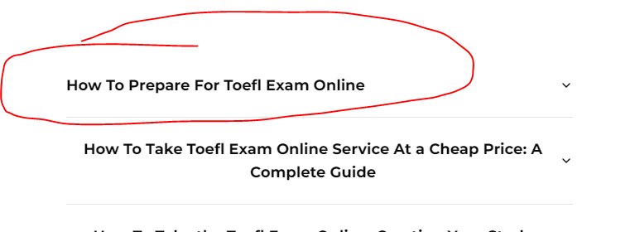

Note: Look at the first faq question which is wrong aligned.

URL # 4:

<https://takingmyclassesonline.com/hesi-exam/>

Paragraph # 1:

We understand the importance of achieving good marks in the admission test, as it plays a crucial role in getting admission in desired universities. However, Through our expert guidance you’re able to achieve good marks in your exams including [toefl exam online](https://takingmyclassesonline.com/toefl-exam-online), CAT exam for nursing and many more. Join Us Now and explore more benefits of paying someone to do my exam.

Note: Add anchor on toefl exam online, and also change the last keyword which is paying someone to do my exam to [paying someone to do my exam.](https://takingmyclassesonline.com/pay-someone-to-take-my-class)

Note: Delete anchor on paying someone to do my exam.

Paragraph # 2:

In today’s rapidly growing environment, Online learning is becoming a prominent solution for learning and developing skills. It helps many students to improve their research skills and allows them to get benefits of vast learning resources. However, many students struggle to get better marks in their exams. However, We arrange many practice exams including HESI practice tests, online PTE academic preparation by helping students to get experience of various exam formats.

Note: change the keyword above to [PTE academic preparation online](https://takingmyclassesonline.com/pte-academic-online)

And also add an anchor link on it!

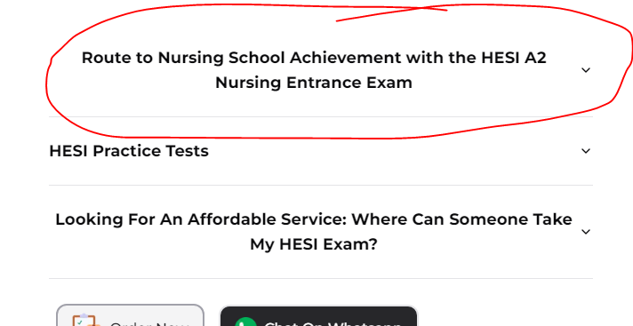

Note: It must be on aligned Left.

URL 5: <https://takingmyclassesonline.com/pte-academic-online>

Point # 1:

Paragraph # 1

In this modern world, We have diverse options for learning and developing skills. Online learning has become a prominent platform for students to seek guidance and enhance their skills. Whether you want to take PTE academic online guidance or need support to [do my GED online test](https://takingmyclassesonline.com/take-my-ged-for-me) , it has become an essential solution for every student.

Note 1: In this modern world, we have diverse

Here above you have to use We ‘w’ in small case

Note 2: PTE academic online guidance or need support to [do my GED online test](https://takingmyclassesonline.com/take-my-ged-for-me) , it has become an essential solution for every student.

Note 2: [do my GED online test](https://takingmyclassesonline.com/take-my-ged-for-me),   
In above case you have to add ‘,’ after keyword ending.

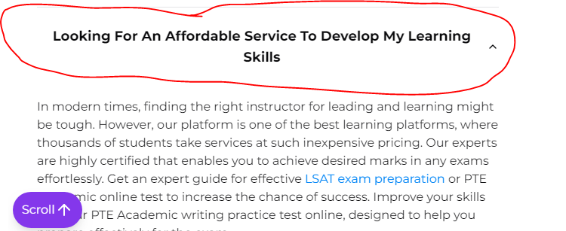

Note: Please all the text to align left.

Point # 3:

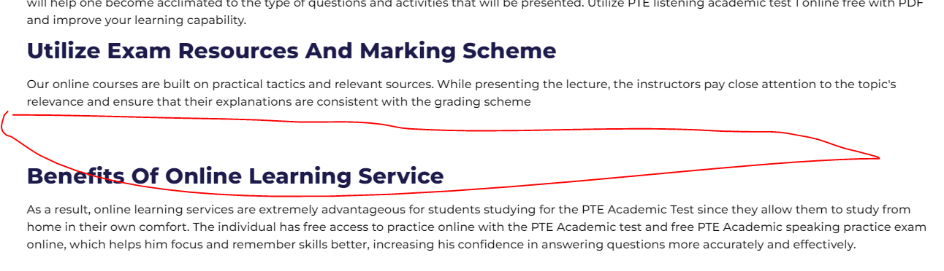

Note: too much Gap between the headings.

URL 6: <https://takingmyclassesonline.com/lsat-exam-prep>

Point # 1:

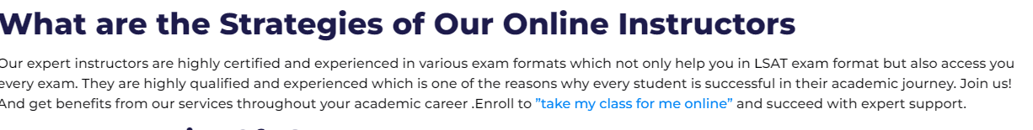  
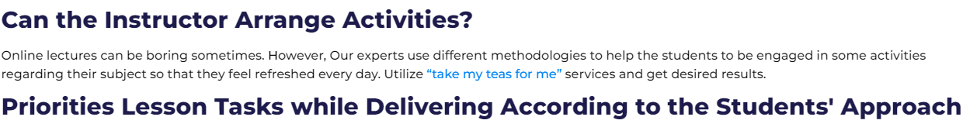

Note: remove anchor from “ inverted commas in both cases.

URL 7: <https://takingmyclassesonline.com/take-my-teas-exam-for-me>

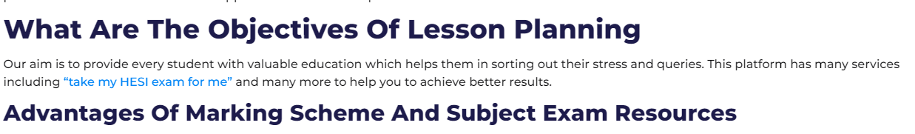

Note: remove anchor from “ inverted commas

URL 8: <https://takingmyclassesonline.com/take-my-ged-for-me>

Point # 1

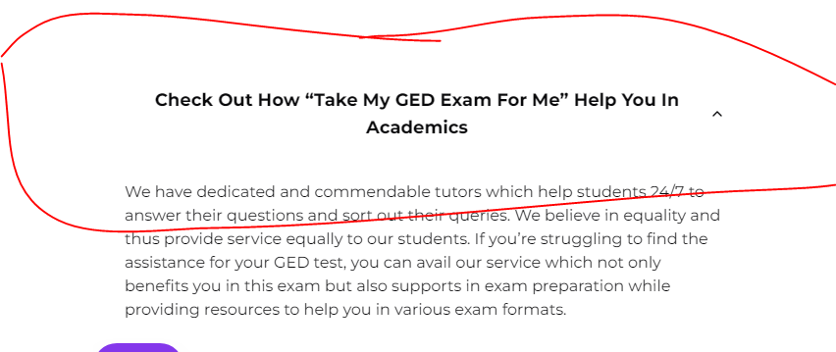

Note: it must be on left align

Point # 2

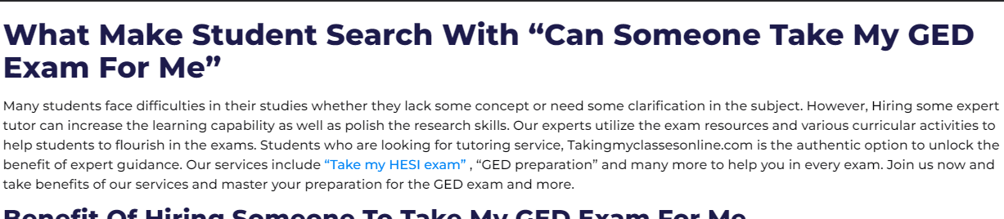

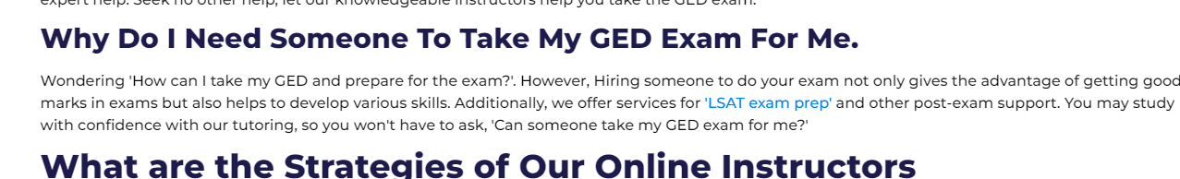

Note: same old error anchor on “ inverted commas in both cases.

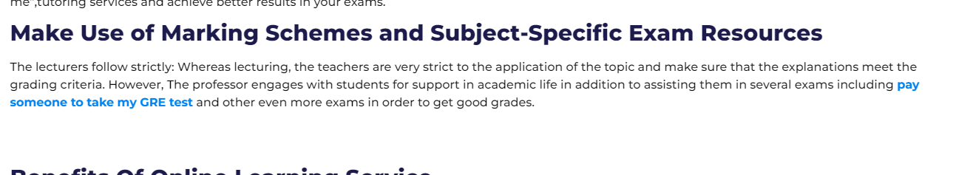

Note: why anchor in bold text?

URL 9: <https://takingmyclassesonline.com/pay-someone-to-take-my-class>

Point # 1



Note: both must be aligned left.

Point # 2

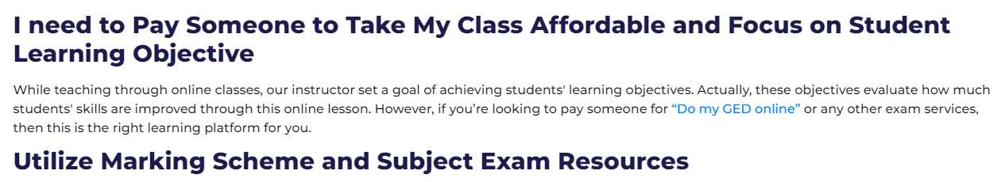

Note: “ commas linked

Last things remaining:

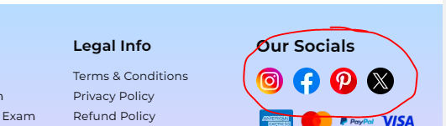

Add linkedin icon with anchor: <https://www.linkedin.com/company/takingmyclassesonline/>